# Homework: SignalR

This document defines the homework assignments from the ["ASP.NET MVC" Course @ Software University](https://softuni.bg/courses/asp-net-mvc/). Please submit as homework a single zip / rar / 7z archive holding the solutions (source code) of all below described problems.

## Import SignalR in your Twitter application

## Show new tweets on the home page with push notifications (using SignalR)

Your task is to show all new tweets as they are being published in real time at the top of the tweets list without refreshing the page. Use SignalR.

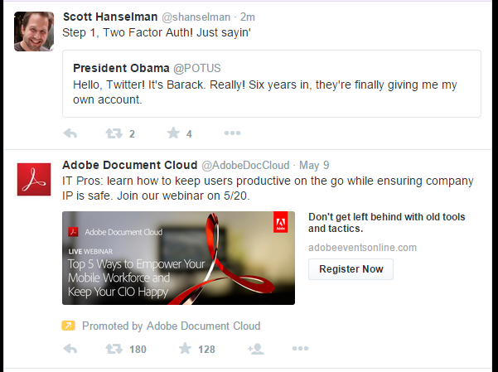

## Notification bubble

Your task is to make a notification bubble showing the number of unread notifications. If you have a new notification, the number of unread notifications should increase. Make it with SignalR.

